East District Championships
On Saturday 8th December, the East District Championships took place at Cupar. With the extra incentive of a place in the East of Scotland team for those that finished in the top eight, hundreds of athletes turned out to race. The overnight frost left the ground rock solid, increasing the difficulty of an already demanding course.
The day’s racing began superbly as a sensational run from Lauren Dickson saw her come home triumphant in the under 13 girls.
This looked to set a platform for others as Magnus Tait booked his place with a 3rd place finish in the under 13 boys.
Picture below shows Lauren and Magnus receiving their medals from Barry Craighead.
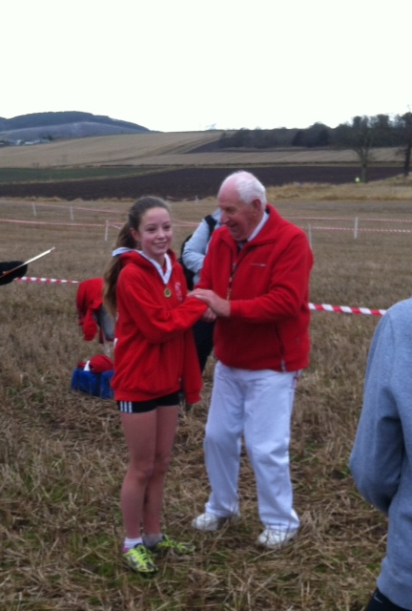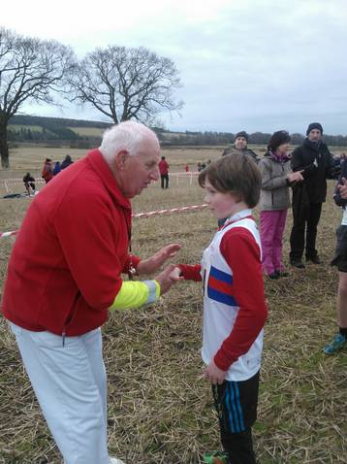

In the under 17/20 women’s race, Amy Frankland went with the leading group early on and hung on well to finish as 2nd under 17 and 9th place overall. This courageous run means Amy too will compete at Holyrood Park on the 5th January. The picture shows Amy, with Kathryn Gillespie (1st) and Louise Mercer (3rd).
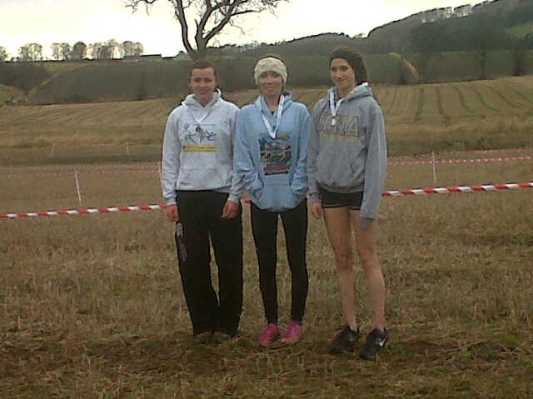

Ross Matheson capped of a fantastic day for Lasswade, winning the under 20 men’s race in dominant fashion. (Sorry Ross I didn’t have a photo from the day so have used one from another race).
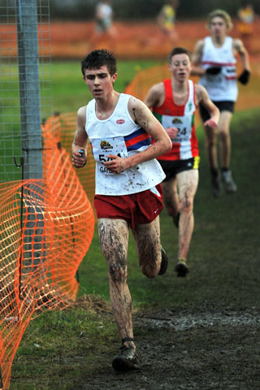
A final congratulations to Lauren Dickson, Magnus Tait, Amy Frankland and Ross Matheson who will all represent the East of Scotland next month.
Results
Under 13 girls – 1st Lauren Dickson 13.48, 32nd Alexandra Massey 16.49, 36th Caroline McKinlay 17.31, 37th Lauren Wilkie 18.05
Under 13 boys – 3rd Magnus Tait 12.58, 25th Jamie Darling 15.01, 27th Ross Mackenzie 15.12, 38th Craig Gallagher 16.15, 40th Euan McKay 16.42, 43rd Adam MacDonald 17.24
Under 15 boys – 15th Kyle Mackenzie 16.40, 32nd Cameron Steven 18.05, 38th Callum Graham 19.34
Under 17 women – 2nd Amy Frankland 22.12
Under 17 men – 20th Callum Clark 25.54
Under 20 men – 1st Ross Matheson 26.56
Senior Women – 75th Linden Nicholson 32.21
Senior Men – 31st Barney Phillips 37.06, 50th Martin Gore 39.16, 93rd Ben Mitchell 42.40

